# Delight Optimization Application

## Team: LMM

The application can be installed by simply clicking the setup file.

When launched, the user loggs in either with an admin accound or an employee one.

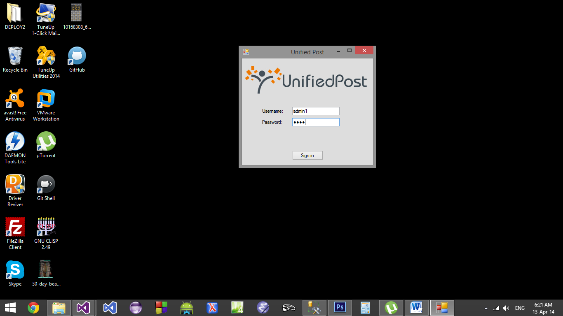

The admin, in its first tab can see and export a customizable report based on employee’s votes.

In the second tab, the groups’ general settings can be viewed, modified and exported. The third tab is dedicated to point allocation.

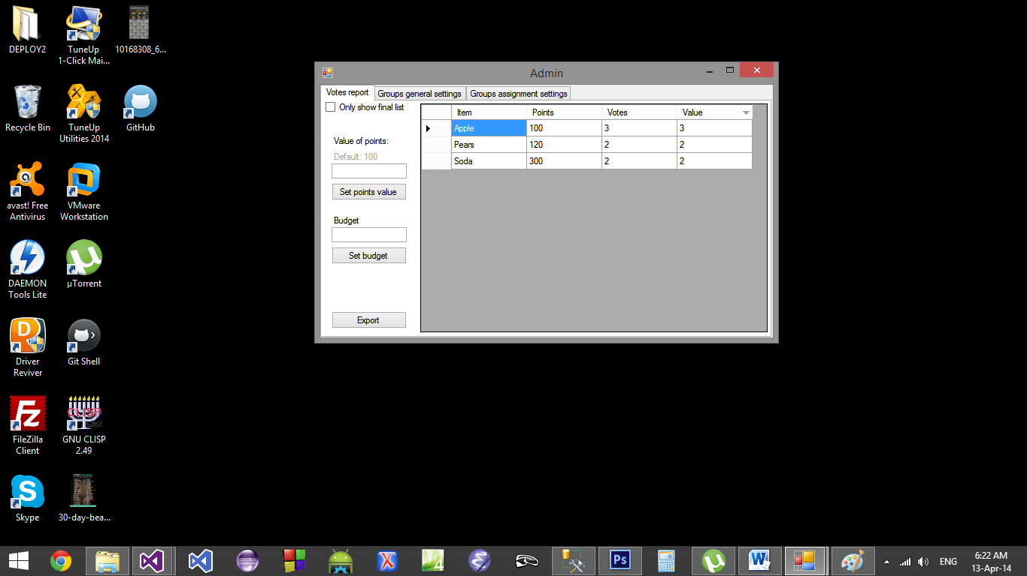

The employees get a form in which they can allocate their points to the wanted item.

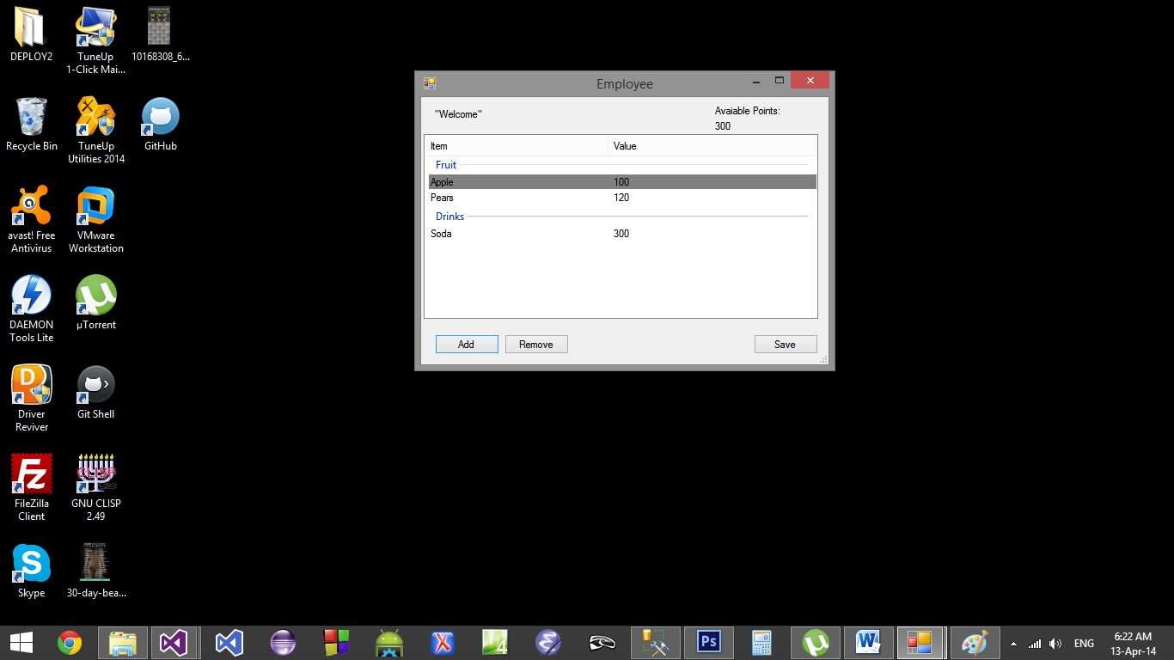

The software was programmed in C# using Microsoft Visual Studio 2013. The database was creates in Microsoft Server Manager and later converted to an Acces file.